Kickstart My Chart

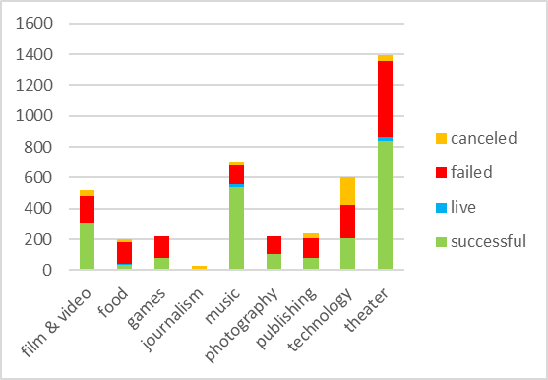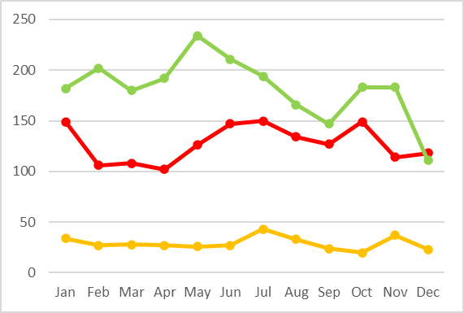

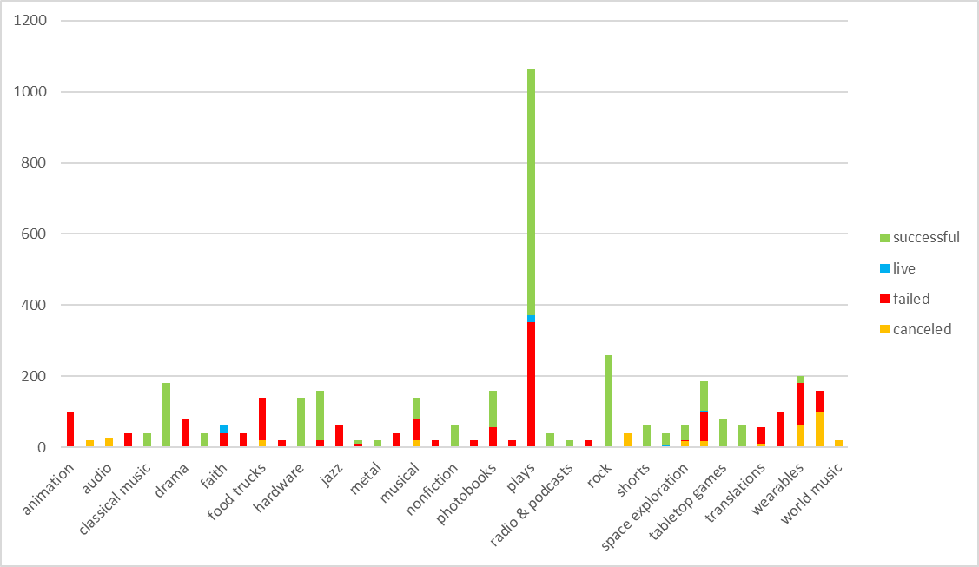

1. Given the provided data, what are three conclusions we can draw about Kickstarter campaigns?
   1. Most people try to raise money for theater projects
   2. Animation projects always fail
   3. More campaigns started in December fail than succeed
2. What are some limitations of this dataset?
   1. Some of the kickstarter campaigns are not set up properly, for example the campaign that had a goal of only $1 and raised over $22,000.
   2. This set of campaigns are very theater heavy
   3. This is only 4,000 out of 300,000, which is only about 1% of the data
3. What are some other possible tables and/or graphs that we could create?
   1. 100% stacked area to see what percentage of the campaigns succeed, fail, and get canceled

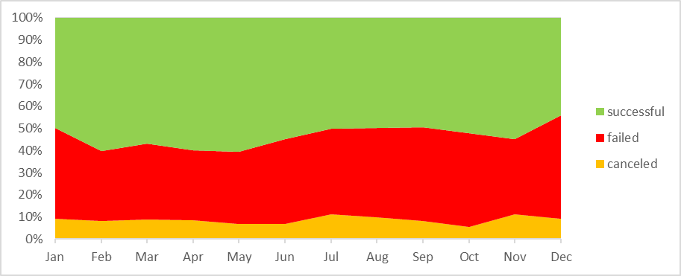

* 1. Pie chart showing category percentages for successful campaigns and a separate one for failed campaigns

